ETM® SIP Application on Cisco ISR(G2)/AXP
Installation and Configuration Guide
For Version 7.0 ETM Application Software
Updated: 03/22/2012
Jacek Materna


Contents
1. Product Overview 4
2. Getting Started 5
3.1 Hardware Requirements 5
3.3 Software Requirements 6
3.3 Performance considerations 6
3. Installation and Configuration 7
4.1 Installing the Router and Service Module hardware 8
4.2 Verifying Service Module Installation 8
4.3 Preparing the Cisco AXP Service Module for Software Installation 9
4.4 Installing ETM® Appliance software on the Cisco AXP Service Module 10
4.5 Licensing the Cisco AXP Service Module 13
4.6 Configuring ETM® Appliance software 14
4.7 Upgrading AXP Host OS on the Cisco AXP Service Module 14
5. Addendum 18
5.1 Non standard deployment options 18
Option 1 – Customer SBC/Service Module/IPPBX – using ETH1 18
Option 2 – Provider/Service Module/IPPBX – no customer installed SBC 18
Option 3 – Customer SBC/Service Module/IPPBX – using ETH0 and ISR Router Backplane for Communication 18
5.2 Dial Peer Notes 20
Sample Dial Peer Configuration 20
Cisco IOS 15.1(2)+ Toll Fraud Features 20
Behavior Before 15.1(2)T 20
Behavior with 15.1(2)T and Later Releases 20
Authorizing ICMP or SSH to external Network Management Devices 21
Multiple Call Controllers on a Trunk 21
AXP User Guide 22
AXP Boot Loader config 22
AXP Boot Loader bypass on SRE only 22

Product Overview
The ETM® SIP Appliance Application for Cisco Integrated Services Routers (ISRs) embeds software-based stateless proxy technology into the routers to provide management and security into branch-office environments.

Cisco Application Extension Platform (AXP) is used as the hosting environment to embed ETM® Appliance software into the routers. The Cisco AXP hosting environment provides the infrastructure to securely host, install, upgrade, and manage the application. This integrated solution complements the existing ETM hardware instrumentation strategy by extending the ETM Appliance further out into the network to provide cost-effective management and security. This enhanced visibility further strengthens the Cisco Borderless Networks initiative that enables organizations and individuals to communicate anytime, anywhere, in any way they wish.
The audience of this document is technical. Please refer to the ETM System user guides for information pertaining to architecture and terminology used in this document.
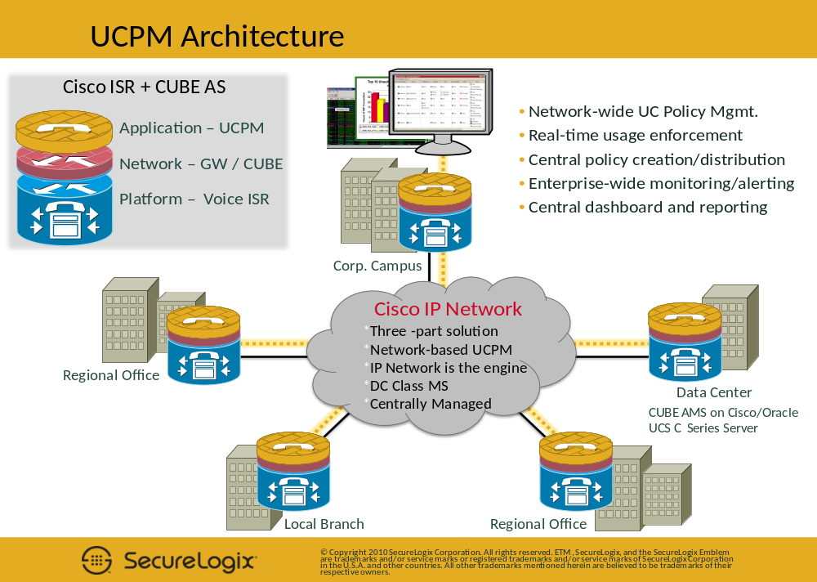

Getting Started
The ETM® Appliance software has hardware and operational requirements that should be analyzed in deciding the best platform for which to run the application.
The ETM® Appliance software package is found on the CD provided. There are a number of initial steps that must be performed in order to load and ensure the software is running on your Cisco ISR.

3.1 Hardware Requirements
ETM® Appliance software is packaged as an AXP version 1.6.1 (1.6) application. As such, certain Cisco hardware is required in order to run it correctly. Cisco provides two generations of what are called “Service Modules” that allow hosting of AXP applications. Newer, more recent generation 2 hardware is recommend; however, the ETM® application will run on generation 1 hardware as well. Figure 1 outlines generation 1 modules that are compatible with Cisco ISRs and the respective AXP versions.
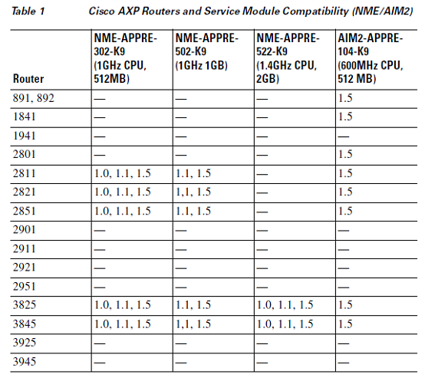
Figure 1
Figure 2 outlines generation 2 modules which are compatible with Cisco ISR’s and the respective AXP versions.

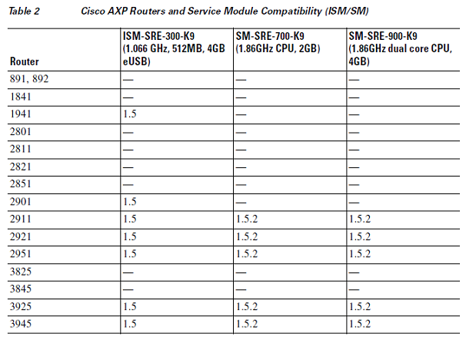
Figure 2

3.3 Software Requirements
ETM® Appliance software running on AXP version 1.6.1 (1.6) requires IOS 15.0+ to be installed on the ISR prior to installation of ETM® software. Refer to IOS documentation for your specific ISR for instructions on how to upgrade and install IOS software images.

3.3 Performance considerations
ETM® Appliance software is designed to scale across a range of Cisco Service Modules. An important factor determining the hardware platform is call capacity. Namely, large concurrent call loads require faster Service Modules. Figure 3 below outlines a normalized performance matrix that compares the performance of all the AXP hosting hardware to one another. This matrix shows a clear picture of capacity scaling as it relates to the appropriate hardware. CPU is the most important performance factor determining ETM® Appliance software performance.
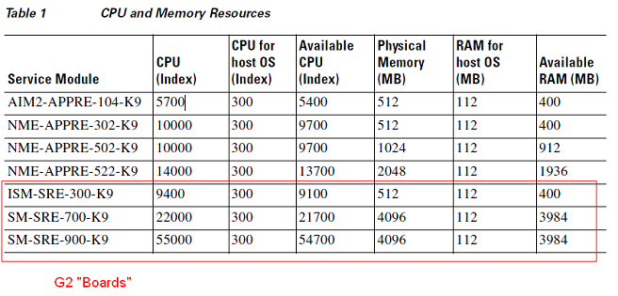
Figure 3
Based on the above performance matrix, a recommended call capacity matrix is proposed in Figure 4 below which will help you identify the hardware necessary to support your call capacities when deploying ETM® Appliance software.
Service Module | Concurrent Calls with Media | Concurrent Calls no Media
NME-APPRE-502-K9 | 125 | 200
NME-APPRE-522-K9 | 150 | 300
SM-SRE-700-K9 | 300 | 500
SM-SRE-900-K9 | 500 | 700

Figure 4

Installation and Configuration
The AXP platform hosts ETM® Appliance software. A Service Module hosts the AXP platform. A Cisco ISR hosts a Service Module. This tiered hosted approach introduces several layers of configuration management. The current ETM® Appliance software does not automatically provision and install itself; however, these features will be available in subsequent releases. Regardless, a number of important steps must be taken to deploy and correctly configure ETM® Appliance software on this platform.

4.1 Installing the Router and Service Module hardware
Refer to the router and service module hardware installation documents on cisco.com for your particular ISR for installation instructions pertaining to Service Modules.

4.2 Verifying Service Module Installation
Once the service module is physically installed and the Cisco router is loaded with the required IOS image and is powered on, proceed with the following steps to ensure that the ISR correctly detects the service module.
Step 1
Verify that the ISR detects the presence of the newly installed service module. Log into the router and enter enable mode by supplying the username and password. Use the following Cisco IOS command to display the FRU (Field Replaceable Unit) reported by the Cisco IOS.
C2851#show diag | include FRU
Product (FRU) Number : CISCO2851
Product (FRU) Number : PVDM2-48
FRU Part Number VWIC-2MFT-T1=
Product (FRU) Number : VWIC2-2MFT-T1/E1
Product (FRU) Number : NME-APPRE-502-K9 < Service Module

Step 2
Use the show hardware command to verify that the router recognized the Service Module
C2851#show hardware
...
Cisco 2851 (revision 53.51) with 241664K/20480K bytes of memory.
Processor board ID FTX1037A0W2
2 Gigabit Ethernet interfaces
17 Serial interfaces
1 terminal line
4 Channelized T1/PRI ports
1 Virtual Private Network (VPN) Module
1 cisco Integrated Service Engine(s) < Service Module
…

4.3 Preparing the Cisco AXP Service Module for Software Installation
The ISR router and Service Module use an internal backplane for communication and require it to be configured prior to configuration of the Service Module itself. In the following commands the Service Module is usually described as “Integrated-Service-Engine” – this applies for the NME type of module interface. If you are using a different type of service module you must substitute the relevant interface name from the following list:
- integrated-service-engine: NME module interface
- internal-service-module: AIM2 module interface
- ism: ISM module interface
- sm: SM module interface

Step 1
Create an internal network subnet that is shared between the router and Service Module for their internal communication. On the router, enter enable mode and use the following Cisco IOS commands to configure this subnet.
C2851#config t <enter config mode
C2851(config)# interface integrated-service-engine 1/0 < config the communication interface
C2851(config-if)#ip address 192.168.2.1 255.255.255.0 < router visible IP
C2851(config-if)#service-module ip address 192.168.2.2 255.255.255.0 < module visible IP
C2851(config-if)#service-module ip default-gateway 192.168.2.1 < point to router-side IP
C2851(config-if)#no shutdown < turn on the interface
C2851(config-if)#end
C2851#wr < save config

Step 2
Now that the communications channel between the router and Service Module are configured, we can proceed in configuring the Service Module. Ensure we set the boot-loader to user the hard drive every boot
C2851#service-module integrated-service-engine 1/0 default-boot set

Step 3
Check the Service Modules status via the router CLI. It must be in a Steady state to proceed. If so please proceed to Step 4.
C2851#service-module integrated-service-engine 1/0 status
Service Module is Cisco Integrated-Service-Engine1/0
Service Module supports session via TTY line 66
Service Module is in Steady state
Service Module heartbeat-reset is enabled
Getting status from the Service Module, please wait..
Application eXtension Platform (AXP) 1.6.1
Online on NME

If you have a fresh Service Module you will most likely have to install the Software via the Boot loader. Please reference the Cisco AXP 1.6.1 User Guide for more information.
If the Service Module has a Host OS on it and it is not in Steady state, something is wrong with the module. First, try reloading or resetting the Module to see if the state goes to Steady; if it is not possible to attain Steady state, try to power cycle to router. If all attempts fail there is most likely something wrong with the blade hardware. Please refer to troubleshooting documentation provided from Cisco.
C2851#service-module integrated-service-engine 1/0 reload <Perform a soft OS reset
or
C2851#service-module integrated-service-engine 1/0 reset <Perform a hardware reset

Step 4
Now that the Service Module is online, session into it via the Router CLI and proceed with its configuration. If the session command fails, then the Service Module is not yet ready for access.
C2851#service-module integrated-service-engine 1/0 session
Trying 192.168.2.1, 2066 ... Open
User Access Verification
Username: <username>
Password:
192-168-2-2# < module CLI

Note: After you enter the password, it might be necessary to hit Enter in order to show the module CLI prompt

4.4 Installing ETM® Appliance software on the Cisco AXP Service Module
The Service Module runs a Host OS that manages one or more Guest OS environments, each of which hosts an AXP application. The Host OS must be properly configured for the Guest OS and application(s) to function correctly.
Note that your Service Module should contain an initial Host OS. Installation of ETM® Appliance software will overwrite this Host OS to ensure that AXP 1.6.1 is installed.
Step 1
Configure the external Service Module ethernet port that will be used to communicate with the outside network. This interface is used to retrieve and install ETM® Appliance software from an FTP/SFTP server using the built-in Service Module installation sub-system. On the Service Module, enter enable mode.
192-168-2-2#config t < config mode
192-168-2-2(config)#interface eth1 < external facing port on module
192-168-2-2(config-if)#ip address 10.1.15.103 255.255.255.0 < IP on LAN
192-168-2-2(config-if)#exit
192-168-2-2(config)#ip route 10.1.1.0 255.255.255.0 10.1.15.1 interface eth1 < LAN GW route
192-168-2-2(config)#end
192-168-2-2#wr < save config
192-168-2-2#ping 10.1.1.150 < verify we can PING the FTP/SFTP
PING 10.1.1.150 (10.1.1.150) 56(84) bytes of data.
64 bytes from 10.1.1.150: icmp_seq=1 ttl=62 time=1.96 ms
….

--- 10.1.1.150 ping statistics ---
5 packets transmitted, 5 received, 0% packet loss, time 8ms
rtt min/avg/max/mdev = 0.901/1.116/1.965/0.425 ms, ipg/ewma 2.018/1.526 ms

Step 2
To properly download and install ETM® Appliance software from the FTP/SFTP server, a few steps must be performed on that server. Copy the following files contained on the provided ETM® Appliance software CD to the same accessible directory on the FTP/SFT server, according to the module generation on which you are installing the software:
- ETM-<pkgversioning>.<nme/sme>pkg
- ETM-<pkgversioning>.<nme/sme>prt1
- axp-installer-k9.<nme/sme>.1.6.1.prt1
- axp-helper-k9-<nme/sme>.1.6.1

Step 3
Execute the following command, using the file location from Step 2 above. The verification, download and reboot of the Service Module will be automated. The entire process will take a few minutes. A number of logging messages will be output to the screen. These are normal unless an error condition is observed and the process seems to stop.
192-168-2-2#software install clean url ftp://10.1.1.150/<path to package>/ETM-< pkgversioning>.pkg username <username>

Note: It is possible that after the installation of the Service Module, it will boot into the ‘Secondary Boot loader’ prompt. If this occurs you will need to set the default boot location to the disk and issue a reboot command:

SE-boot-loader>boot disk < Set default boot location to Disk
SE-boot-loader>reboot

Step 4
With the ETM® Appliance software installed and Service Module restarted, some of the configuration items done previously are deleted since a new Host OS has been loaded. These will be reconfigured in a later step; however, first check for the presence of ETM® Appliance software to ensure that it was installed properly.
192-168-2-2#show software packages | include ETM
- ETM (SecureLogix ETM Appliance) (<Version>)
Step 5
Additional tasks must be performed prior to configuring the ETM® Appliance software itself. The Service Module is configured by default to use the Router as its NTP master to obtain time information. This functionality must be turned OFF.
192-168-2-2#config t <enter config mode
192-168-2-2 (config)# app-service ETM < Enter ETM config mode
192-168-2-2 (config-ETM)# shutdown < Shutdown ETM Guest OS for now
192-168-2-2 (config-ETM)# exit
192-168-2-2 (config)# no ip ssh server < ETM hosts its own SSH server in its Guest OS environment
192-168-2-2 (config)# no ntp server
192-168-2-2 (config)# end
192-168-2-2#wr < Save config

Step 6
Now that the Service Module has been configured, we need to turn the ETM® back on prior to configuring it.
192-168-2-2#config t <enter config mode
192-168-2-2 (config)# app-service ETM < Enter ETM config mode
192-168-2-2 (config-ETM)# no shut < Turn ETM Guest OS back on
192-168-2-2 (config-ETM)# exit
192-168-2-2 (config)# end
192-168-2-2#wr < Save config

Step 7
In order for ETM® Appliance software to be able to participate in SIP signaling and RTP/RTCP media paths, virtual network interfaces must be created on top of the eth1 interface. The Service Module must be configured to provide at least 1 interface, with 4 recommended. Each provides the following functions:
eth1 – Communication channel to Mgt. Server
eth1:1 – External trunk Interface for SIP signaling
eth1:2 – Internal trunk Interface for SIP signaling (Optional if different IP than External)
eth1:3/eth1.X – Media interface that will be used for Media NAT functions (Optional if no Media or different IP than External/Internal)

The IP addresses chosen for each interface are based on your deployment plan. It is critical that IP routes be setup so that each of the above interfaces is able to communicate with the network on which they are configured. Refer to the ETM System 5000 series guide for more information.

192-168-2-2#config t <enter config mode
192-168-2-2 (config)#interface eth1
192-168-2-2 (config-if)#ip address 10.1.15.103 255.255.255.0
192-168-2-2 (config-if)#exit
192-168-2-2 (config)#ip route 10.1.0.0 255.255.0.0 10.1.15.1 interface eth1 < Default Gateway
192-168-2-2 (config)#interface eth1:1
192-168-2-2 (config-if)#ip address 10.1.15.104 255.255.255.0
192-168-2-2 (config-if)#exit
192-168-2-2 (config)#interface eth1:2
192-168-2-2 (config-if)#ip address 10.1.15.106 255.255.255.0
192-168-2-2 (config-if)#exit
192-168-2-2 (config)#interface eth1:3
192-168-2-2 (config-if)#ip address 10.1.15.105 255.255.255.0
192-168-2-2 (config-if)#exit

- The following optional IP Routes are very important, you must have a route set up for every subnet that has a media origination or destination or you may end up with one way audio. Add a route for every ip phone subnet as well as a route to the call manager subnet.

(Optional) 192-168-2-2 (config-if)#ip route X.X.X.X(ip) X.X.X.X(mask) X.X.X.X(gw) interface Y < GW routes
(Optional) 192-168-2-2 (config-if)#ip route X.X.X.X(ip) X.X.X.X(mask) interface Y < routes

192-168-2-2 (config-if)#app-service ETM
192-168-2-2 (config-ETM)#hostname ETM-6.1.0-AXP < Optional, your choice of hostname
192-168-2-2 (config-ETM)#bind interface eth1 < Export interface to ETM Guest OS
192-168-2-2 (config-ETM)#bind interface eth1:1 < Export interface to ETM Guest OS
192-168-2-2 (config-ETM)#bind interface eth1:2 < Export interface to ETM Guest OS
192-168-2-2 (config-ETM)#bind interface eth1:3 < Export interface to ETM Guest OS

192-168-2-2 (config-ETM)#no shutdown < Boot the ETM Guest OS

192-168-2-2 (config-ETM)#end
192-168-2-2#wr < save config
Step 7
The configuration of the Service Module is complete and it must be reset, along with the ETM® Appliance software, in order to effect the changes.
192-168-2-2#reload < reboot the Service Module, confirm Y

4.5 Licensing the Cisco AXP Service Module
By default, the Service Module Host OS includes a temporary license that enables software to run for a period of 60 days. It is important to license the Service Module before this time expires to ensure uninterrupted service. Refer to the Service Module documentation for information about licensing your Service Module.

4.6 Configuring ETM® Appliance software
Current ETM® Appliance software is designed to be initially configured via its own CLI prior to entering an operational state.
Step 1
If you configured everything correctly you should be able shell directly into the Guest OS unauthenticated via the Service Module CLI. This first login will setup the ETM password credentials for remote SSH access automatically.
192-168-2-2#app-service ETM < Local access via AXP CLI
192-168-2-2(exec-ETM)#connect console
eth0 MAC address: <mac address> < Output
Changing password for user ETM.
passwd: all authentication tokens updated successfully.
New password is <password>
[ETM@ETM /]$ < ETM CLI

Step 2
Next, step through the ETM configuration wizard. After it is completed, configure ETM® Appliance software SIP Trunking information from the Management Server. Please refer to the ETM System user guides for further information.
[ETM@ETM ~]$cd opt/slc
[ETM@ETM ~]$sudo ./ETM_5000_configure.pl

4.7 Upgrading AXP Host OS on the Cisco AXP Service Module
The Service Module runs a Host OS that manages one or more Guest OS environments, each of which hosts an AXP application. The Host OS must be upgraded outside of the ETM Management Server along with its registry of Guest OS’s for the Guest OS and application(s) to function correctly.
Note that this process outlines a situation where your Service Module already contains initial Installation of ETM® Appliance software as per section 4.4. This process will outline the steps required to upgrade the Host OS.
Please reference Section 4.3 to login to the Service Module.
Step 1
The ETM software on the Service Module manages security rules that prevent unauthorized traffic from contacting the Service Module. In order to upgrade the system, these rules need to be disabled prior to attempting to download any software from an FTP server.
- From within the ETM® Performance Manger
- Highlight the SIP Span that is communicating to the Cisco Service Module from above, right click and open ASCII Management
- Enter command: netfilter disable
Step 2
Configure the external Service Module ethernet port that will be used to communicate with the outside network. This interface is used to retrieve upgrade packages from an FTP/SFTP server using the built-in Service Module installation sub-system. On the Service Module, enter enable mode.
192-168-2-2#config t < config mode
192-168-2-2(config)#interface eth1 < external facing port on module
192-168-2-2(config-if)#ip address 10.1.15.103 255.255.255.0 < IP on LAN
192-168-2-2(config-if)#exit
192-168-2-2(config)#ip route 10.1.1.0 255.255.255.0 10.1.15.1 interface eth1 < LAN GW route
192-168-2-2(config)#end
192-168-2-2#wr < save config
192-168-2-2#ping 10.1.1.150 < verify we can PING the FTP/SFTP
PING 10.1.1.150 (10.1.1.150) 56(84) bytes of data.
64 bytes from 10.1.1.150: icmp_seq=1 ttl=62 time=1.96 ms
….

--- 10.1.1.150 ping statistics ---
5 packets transmitted, 5 received, 0% packet loss, time 8ms
rtt min/avg/max/mdev = 0.901/1.116/1.965/0.425 ms, ipg/ewma 2.018/1.526 ms

Step 3
Identify the versions of existing software installed on the Service Module:
192-168-2-2#show software versions
Application eXtension Platform (AXP) version (<AXP Host OS Version>)
Technical Support: http://www.cisco.com/techsupport Copyright (c) 1986-2009 by Cisco Systems, Inc.

Components:
- ETM version (<ETM Version>)

Identify the appropriate ETM upgrade software package for your installed versions by mapping the AXP Host OS version and ETM Version to a package name:

Service Module | Current AXP Host OS Version | Current ETM Version | Upgrade Package(s)  To Choose
NME-APPRE-502-K9 | 1.5.2 | 6.1.26 | ETM-6.1.26.161.nme
NME-APPRE-522-K9 | 1.5.2 | 6.1.26 | ETM-6.1.26.161.nme
SM-SRE-700-K9 | 1.5.2 | 6.1.26 | ETM-6.1.26.161.sme
SM-SRE-900-K9 | 1.5.2 | 6.1.26 | ETM-6.1.26.161.sme
NME-APPRE-502-K9 | 1.5.2 | 6.1.53 | ETM-6.1.53.161.nme
NME-APPRE-522-K9 | 1.5.2 | 6.1.53 | ETM-6.1.53.161.nme
SM-SRE-700-K9 | 1.5.2 | 6.1.53 | ETM-6.1.53.161.sme
SM-SRE-900-K9 | 1.5.2 | 6.1.53 | ETM-6.1.53.161.sme

WARNING: Incorrectly choosing the wrong upgrade package could cause your ETM Appliance installation to fail and or be permanently corrupted. If you are unsure of the mapping or cannot find an appropriate upgrade package, please contact SecureLogix.

Step 4
To properly download and upgrade the upgrade package on the Service Module and upgrade the AXP Host OS, a few steps must be performed on the SFTP/FTP server. Copy the following files contained on the provided ETM® Appliance software CD to the same accessible directory on the FTP/SFTP server, according to the module generation on which you are installing the software:
- axp-installer-k9.<nme/sme>.1.6.1.prt1
- axp-helper-k9-<nme/sme>.1.6.1
- ETM-<pkgversioning>.<nme/sme>pkg
- ETM-<pkgversioning>.<nme/sme>prt1

Step 5
Execute the following command, using the file location from Step 3 above. The verification, download and reboot of the Service Module will be automated. The entire process will take a few minutes. A number of logging messages will be output to the screen. These are normal unless an error condition is observed and the process seems to stop.
192-168-2-2#software install package url ftp://10.1.1.150/<path to package>/<ETM Upgrade Package>.pkg username <username>

Step 6
With the AXP Host OS upgraded to newest version, check for the presence of ETM® Appliance software to ensure that it was not impacted.
192-168-2-2# show software versions | include AXP
Application eXtension Platform (AXP) version (<AXP Host OS Version>)

192-168-2-2# show software packages | include ETM
- ETM (SecureLogix ETM Appliance) (<ETM Version>)

WARNING: Your ETM Appliance version should NOT have changed after the upgrade. Only your AXP OS version should have changed. If the ETM appliance version has changed, you could have permanently corrupted your Appliance installation, please contact SecureLogix.

Step 7
We must now revert the changes made to the security rules on the Service Module.
- From within the ETM® Performance Manger
- Highlight the SIP Span that is communicating to the Cisco Service Module from above, right click and open ASCII Management
- Enter command: netfilter enable. This command rebuilds the iptables of the ETM® Application on the Service Module.
Step 8
Your Service Module configuration should not have changed after the upgrade. To complete the upgrade process of the ETM Appliance Software on the Guest OS, proceed to use the ETM Management Server. Reference your ETM User Guide for more information.

Addendum

Non standard deployment options

Option 1 – Customer SBC/Service Module/IPPBX – using ETH1
The Cisco Service Module is logically inline between the SBC and the IPPBX, the external Ethernet port on the Service Module is being used for network communications, the SIP trunk endpoints, and the ETM® Management Server are accessible via the Ethernet connection on the Service Module. It is recommended that you create the private network as listed in step 1 of section 4.3 above; however in step 6 of section 4.3 assign one IP Address to be used for the Communications Channel to the ETM® Server, Signaling Proxy and Media Proxy.
Also see addendum section about Dial Peers and CISCO IOS 15.1(2)+ regarding the new Toll Fraud Prevention Feature.

Option 2 – Provider/Service Module/IPPBX – no customer installed SBC
The Cisco Service Module is logically inline between the Providers SBC and the IPPBX. In this type of installation you will need to assign several IP addresses to account for the public and private networks that the Cisco Service Module will be communicating to in step 6 of section 4.3, see below.
Eth1 – Customer facing IP Address that will be used for communication with the ETM® Management Server
Eth1:1 – Provider facing address that will be used as the External SIP Signaling Interface to the Provider. This is the IP Address that the provider will point its traffic towards and also the IP Address that the Provider will receive outbound traffic from.
Eth1:2 – Customer facing IP Address that will be used as the Internal SIP Signaling Interface to the IPPBX. This is the IP Address that the IPPBX will point its outbound traffic towards and also the IP Address that the IPPBX will receive inbound traffic from.
At this point you have the flexibility to create external/internal interfaces for media using ETH1:3 and ETH1:4 or allow the ETH1:1 and ETH1:2 to act as both Signaling and Media Proxies.

Option 3 – Customer SBC/Service Module/IPPBX – using ETH0 and ISR Router Backplane for Communication
The Cisco Service Module is logically inline between the Customer SBC and the IPPBX, the external Ethernet port on the Service Module is not being used for network communications. In this example you will create a network between the ISR Router and Cisco Service Module, however it will not be a private network.
IP Addresses on the internal network will be used to communicate with the ETM® Management Server, Customer SBC and IPPBX.
The advantage of this type of deployment is that it removes network traffic that would occur on the switch that would be connected to the ETH1 port of the Cisco Service Module and with that it removes a point of failure.
The disadvantage of this type of deployment is that it imposes a relationship between the state of the Router and the Service Module. Namely, if the router is rebooted or restarted for any reason the Service Module’s network operations could go down. In the default deployment model, the Service Module is completely decoupled from the router and uses it only for Power supply.
See example configuration below:
Router config:
interface SM2/0
ip address 10.114.1.1 255.255.255.240 ←IP Address which is a part of the customers pool of addresses.
service-module ip address 10.114.1.3 255.255.255.240 ←IP Address which is a part of the customers pool of addresses.

!Application: Online on SME
service-module ip default-gateway 10.114.1.1

Service Module:
interface eth0
ip address 10.114.1.3 255.255.255.240 ←IP Address which is a part of the customers pool of addresses.
exit

interface eth1
shutdown
exit

interface mgf0
exit

no ip ssh server

app-service ETM
bind interface eth0
hostname DC-ETM-AXP
exit

5.2 Dial Peer Notes

Sample Dial Peer Configuration
voice service voip
no ip address trusted authenticate ← See Cisco IOS 15.1(2)+ Toll Fraud Features
address-hiding
allow-connections h323 to h323
allow-connections h323 to sip
allow-connections sip to h323
allow-connections sip to sip

dial-peer voice 15 voip
description Outgoing dial-peer to CallManager
destination-pattern 312.......
session protocol sipv2
session target ipv4:10.140.5.8 ←Call manager or subscribers IP Address
voice-class codec 1
voice-class sip outbound-proxy ipv4:10.100.5.22 ←ETM on the Cisco Service Module
voice-class sip early-offer forced
dtmf-relay rtp-nte
fax-relay sg3-to-g3
fax rate 14400
fax protocol t38 version 0 ls-redundancy 0 hs-redundancy 0 fallback pass-through g711ulaw
no vad

Cisco IOS 15.1(2)+ Toll Fraud Features

Behavior Before 15.1(2)T
For all IOS releases before 15.1(2)T, the default behavior for IOS voice gateways is to accept call setups from all sources. As long as voice services are running on the router, the default configuration will treat a call setup from any source IP address as a legitimate and trusted source to set a call up for. Also, FXO ports and inbound calls on ISDN circuits will present secondary-dial tone for inbound calls, allowing for two-stage dialing. This assumes a proper inbound dial-peer is being matched.

Behavior with 15.1(2)T and Later Releases
Starting with 15.1(2)T, the router’s default behavior is to not trust a call setup from a VoIP source. This feature adds an internal application named TOLLFRAUD_APP to the default call control stack, which checks the source IP of the call setup before routing the call. If the source IP does not match an explicit entry in the configuration as a trusted VoIP source, the call is rejected.
For further explanation see: http://www.cisco.com/en/US/tech/tk652/tk90/technologies_tech_note09186a0080b3e123.shtml

Authorizing ICMP or SSH to external Network Management Devices
The ETM Linux OS that is configured locks down network access to authorized Endpoints and the ETM® Management Server. To enable additional parties to PING the host or enable SSH access, enable Remote Clients in the Management Server interface.
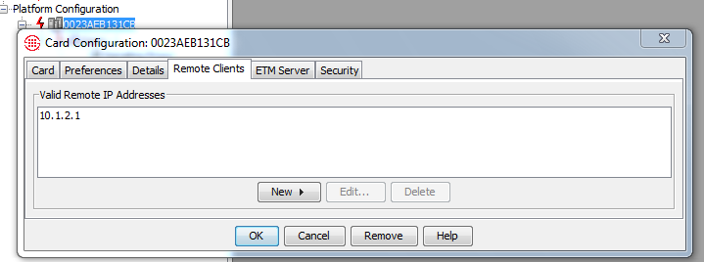

Multiple Call Controllers on a Trunk
WARNING: The ETM System supports use of DNS under the assumption that all Call Controllers or endpoints associated with the SAME DNS name participate as a pool of redundant resources. Namely, the nodes MUST operate in a backup model whereby Calls are being processed by 1 NODE at any given time.

- Modify the hosts file and enter all the IP addresses of the nodes and ensure the header reads as follows:

order hosts, bind, multi on
156.25.27.103 CUCM CUCM.SUBSCRIBER.COM
156.25.27.122 CUCM CUCM.SUBSCRIBER.COM

- Modify the Trunk(s) in ETM Performance manager to use domain name instead of an IP endpoint.
- Below are several commands that control how we manage trunks in a DNS environment.
SIP VIA FORCE on|off--configure how SIP messages are routed to next hop
ON: route SIP packets based on trunk configuration
OFF: route SIP packets based on received VIA header
SIP VIA TOGGLE on|off--route outgoing message to peer that last sent message (on)

SIP VIA SHOW--display the force and toggle configuration

AXP User Guide


AXP Boot Loader config
The AXP Boot-loader guide can be found at
http://www.cisco.com/en/US/docs/interfaces_modules/services_modules/ax/1.6/user/guide/axpap1.html#wpxref86381

AXP Boot Loader bypass on SRE only
To install a base image instead of going through the boot helper mode you can use the boot loader to load the AXP Operating system via the link above or use the standard IOS command:
Router#service-module sm 0/0 install url ftp://x.x.x.x/ axp-k9.sme.1.6.1.pkg

